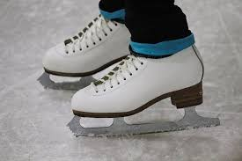

Tavistock & District Skating Club
1969 - 2019

Come celebrate 50 years with us!

Saturday September 21st

Free Skate – 11 a.m. to 1 p.m.

Refreshments & Social – 11 a.m. to 2 p.m. (Arena Upper Hall)

